For the parametric choice (λA,λB,λAB,λBA) = (2,2.5,1.5,1.3) and sample sizes (80,100,120,150,200,300) :

> power

[,1] [,2] [,3]

[1,] 0.1808 0.6358 0.3926

[2,] 0.2397 0.7139 0.4518

[3,] 0.3011 0.7836 0.5024

[4,] 0.3859 0.8491 0.6008

[5,] 0.5464 0.9376 0.7275

[6,] 0.7736 0.9883 0.8876

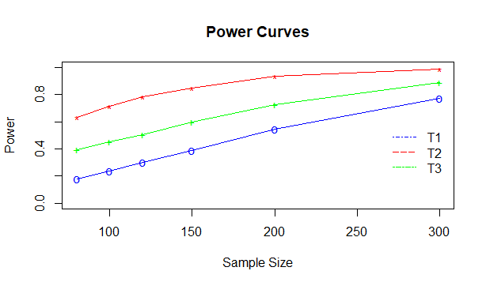

For the parametric choice (λA,λB,λAB,λBA) = (1.6,2.2,1.4,1.2) and sample sizes (80,100,120,150,200,300) :

> power

[,1] [,2] [,3]

[1,] 0.3137 0.7837 0.5489

[2,] 0.4106 0.8572 0.6294

[3,] 0.4986 0.9102 0.6979

[4,] 0.6100 0.9512 0.7991

[5,] 0.7771 0.9868 0.9025

[6,] 0.9380 0.9992 0.9816

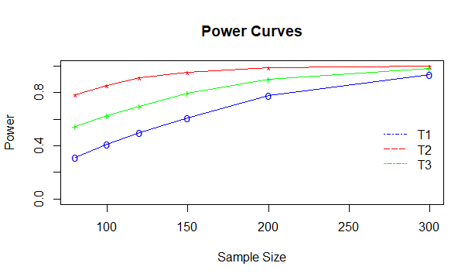

For the parametric choice (λA,λB,λAB,λBA) = (2.9,3.3,2.7,2.3) and sample sizes (80,100,120,150,200,250,300) :

> power

[,1] [,2] [,3]

[1,] 0.1953 0.5484 0.3194

[2,] 0.2648 0.6277 0.3641

[3,] 0.3253 0.6960 0.3994

[4,] 0.4180 0.7662 0.4926

[5,] 0.5754 0.8784 0.6198

[6,] 0.7042 0.9266 0.6902

[7,] 0.7959 0.9625 0.7831

